Databases - project

by Bartosz Sobczak

1. Analysis

Customer: Car insurance company based in the US.

User: Employees of the company (Full access), customers of the company (can display only a small part of the content, i.e. data connected with their account on the company’s website).

Purpose of the database: Storing and providing information about Customers’ accidents, damages, payments from the insurance policies.

Assumptions/Limitations: The company operates and records accidents ONLY in one country (United States). The only type of vehicle the database supports is cars.

Sample queries:

* select all the involved in an accident
* display number of insured cars made in 2002 and in 2006
* select the person with the highest amount of insurance policies
* select all the damages caused by a person
* show if an insurance payment has been received
* compute average number of involved in accidents
* select all the accidents that happened in the NYC

2. ERD

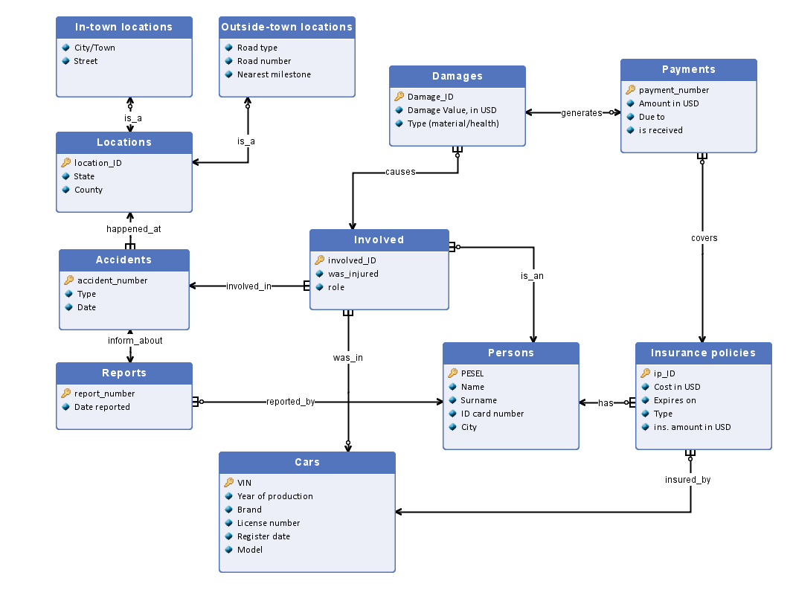

3. Description of ERD: entity sets, attributes and relationships

* Accidents - all accidents that have happened to customers of the company. Size: 500,000

- accident_number (integer from 1 up to 500,000) - primary key

- Type (short desc. of accident like frontal collision or hitting road infrastructure object. 100 characters)

- Date (in date format DD/MM/YYYY)

* Locations - all locations in the country, where registered accidents happened. Size =s.of Accidents

- location_ID (11 digits) – primary key

- State (20 ch.)

- County (30 ch.)

* In-town locations - locations of accidents that happened on the territory of a certain city/town/village. Size = 300,000

- location_ID (11 digits) – primary key (foreign key)

- City/Town (20 characters)

- Street (40 ch.)

* Outside-town locations - locations of accidents that happened on the territory that doesn’t belong to any town, e.g. on a highway or countryside road.

- location_ID (11 digits) – primary key (foreign key)

- Road Type (e.g. interstate or countryside road) (30 ch.)

- Road number (int. up to 10,000)

- Nearest milestone (milestone number) (int up to 10,000)

* Reports - set of reports of accidents. Any accident can be recorded only once, therefore Size = s. of Accidents.

- report_number (int up to 500,000) - primary key

- Date reported (see Date in accidents)

* Persons - all customers, potential customers and involved in accidents. Size: 100,000

- SSN (9 digits) - primary key

- Name (20 ch.)

- Surname (50 ch.)

- ID card number (3 letters and 6 digits)

- Address (50 ch.)

* Involved - involved in registered accidents. Can be customers of the company or not.

- involved_ID (10 ch.) - primary key

- was_injured (binary, yes/no)

- role (20 ch.)

* Cars - all cars that took part in registered accidents or are insured by the company. Size: 1,000,000

- VIN (Vehicle Identification Number) (10 ch.) - primary key

- Year of production (int. between 1900 and 2022)

- Brand (20 ch.)

- License number (8 ch.)

- Register date (date)

- Model (20 ch.)

* Damages - one entity of this set represents damage done to a single person, by other involved, themselves or other factors. Size: 2,000,000

- Damage_ID (10 ch.) - primary key

- Damage Value, in USD (a number up to 100 million)

- Type (material/health) (binary)

* Payments - payments that are provided (from insurances) to a single person to cover the damage. Size: 2,000,000

- payment_number (int. equal to the size of the set) - primary key

- Amount in USD (a number up to 100 million)

- Due to (date)

- is_received (binary)

* Insurance Policies - all insurance policies provided to customers by the company.

- ip_ID (10 ch.) - primary key

- Cost in USD (per month) (a number up to 1,000,000)

- Amount in USD

- Expires on (date)

- Type (eg. liability insurance) (40 ch.)

- ins. amount in USD (amount insured) (a number up to 100,000,000)

Relationships

is_an  
Entity 1: Involved  
Entity 2: Persons  
Type of relationship: 0..1 : 1  
Description: A person might be involved in accident

has  
Entity 1: Persons  
Entity 2: Insurance policies  
Type of relationship: 1 : 0..n  
Description: A persons might have many insurance policies

insured_by  
Entity 1: Cars  
Entity 2: Insurance policies  
Type of relationship: 1 : 0..n  
Description: A car might be insured by several insurance policies

reported_by  
Entity 1: Persons  
Entity 2: Reports  
Type of relationship: 1 : 0..n  
Description: A person can make many reports (of accidents)

generates  
Entity 1: Damages  
Entity 2: Payments  
Type of relationship: 1 : 0..1  
Description: Damage might generate a payment from insurance. A damage doesn’t generate a payment, when, for example, the person that caused the damage doesn’t have comprehensive cover/ insurance.

covers  
Entity 1: Payments  
Entity 2: Insurance policies  
Type of relationship: 0..n : 1  
Description: Many payments might be covered from a single insurance policy

was_in  
Entity 1: Involved  
Entity 2: Cars  
Type of relationship: 1..n : 0..1  
Description: Person involved in an accident could be in a certain car

causes  
Entity 1: Involved  
Entity 2: Damages  
Type of relationship: 1 : 0..n  
Description: An involved could cause damages

inform_about  
Entity 1: Reports  
Entity 2: Accidents  
Type of relationship: 1 : 1  
Description: One report informs about one accident

involved_in  
Entity 1: Involved  
Entity 2: Accidents  
Type of relationship: 1..n : 1  
Description: Many involved could take part in an accident

happened_at  
Entity 1: Accidents  
Entity 2: Locations  
Type of relationship: 1 : 1  
Description: An accident happened at a certain location

is_a  
Entity 1: Locations  
Entity 2: Outside-town locations  
Type of relationship: 1 : 0..1  
Description: A location of an accident can be outside any town

is_a  
Entity 1: Locations  
Entity 2: In-town locations  
Type of relationship: 1 : 0..1  
Description: A location of an accident can be in a town

4. RDB Schema

Locations (location_ID,City/Town, Street, State, County, accident_number REF Accidents)

In-town locations (location_ID REF Locations, City/Town, Street)

Outside-town locations (location_ID REF Locations, Road type, Road number, Nearest milestone)

Accidents (accident_number,Type, Date)

Reports (report_number, Date reported, accident_number REF Accidents, SSN REF Persons)

Persons (SSN, Name, Surname, ID card number, Address)

Involved (involved_ID, was_injured, role, SSN REF Persons, VIN REF Cars, accident_number REF Accidents)

Insurance policies (ip_ID, Cost in USD, Amount in USD ,Expires on, Type, ins. amount in USD, SSN REF Persons, VIN REF Cars)

Cars (VIN, Year of production, Brand, License number, Register date, Model)

Damages (Damage_ID, Damage Value in USD, Type, involved_ID REF Involved)

Payments (payment_number, Amount in USD, Due to, is received, Damage_ID REF Damages, ip_ID REF Insurance policies)